Graham Ward reaction- Shifnal Town 1-0 AFC Bridgnorth
30/09/2020
@chaguejones
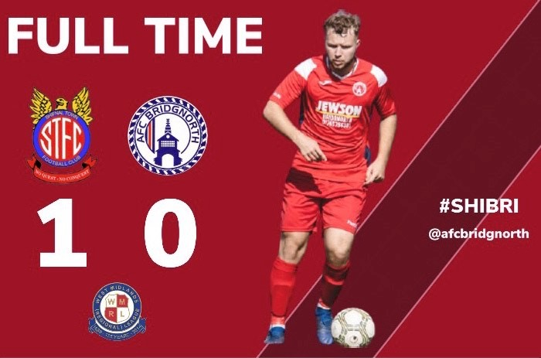
Graham Ward reacts to his side’s loss away at Shifnal Town in the WMRL.
AFC Bridgnorth narrowly fell to defeat at the hands of Shifnal Town in last night’s WMRL fixture.
Tom Hill’s goal after 22 minutes was enough to capture the three points for Shifnal, but Ward believes there was some positive signs shown from the Meadowmen.
On the performance:
“I was really proud of my team last night. I asked them to get the ball down and play to take the game to Shifnal, and they did. One moment of quality from their attackers was what ultimately decided the game.
“How we matched them, shows how far this bunch of lads have come in such a short space of time. It wasn’t a long time ago when we lost 4-1 here in the FA Cup. This team will keep improving, every week and look better as the games go by.
“It is hard to take because I thought we deserved a point from the game, but credit to Shifnal, they are the favourites for a lot of people and defended very well in periods of the game. To have someone like Shifnal on the back foot shows how far little old AFC Bridgnorth have come.”
On Andy Hartlebury’s early injury:
“I think their goal actually came from the injury. If the injury didn’t happen, I know that Andy would’ve prevented it. To lose him so early on was very hard to adjust to. I thought Harry and Jase handled the job very well.
“You just can’t put a price on experience and dressing room presence, and that’s what Andy brings. He gives the lads a boost when it comes to match day and he’s vital for derby games like this because he knows what they’re all about. He won’t be rushed to get back, he comes back when he is right and fully fit, no sooner. Andy is massive for this club and I can’t hide my disappointment. Not a game has gone by this season where we have had to make big calls to the subs bench, so it’s tough at the moment.”
On the tough start in the league:
“I think it’s been a hard start but Saturday will be the same. It will show us as a group of players where we are and helps us understand what we need to improve on. I know what these guys are capable of, just from watching them train. I have no doubt that the goals through Knowler (Charlie Knowles) will start to come and the win will come sooner rather than later.”

